POWER BI DASHBOARD CHALLENGE

TASK 8 – DASHBOARD VISUALIZATION (PART 3)
● Enhance dashboard with:
○ Filters & Slicers
○ Drill-downs
○ Bookmarks & Buttons for navigation
● ✅ Task: Make the dashboard interactive and user-friendly.
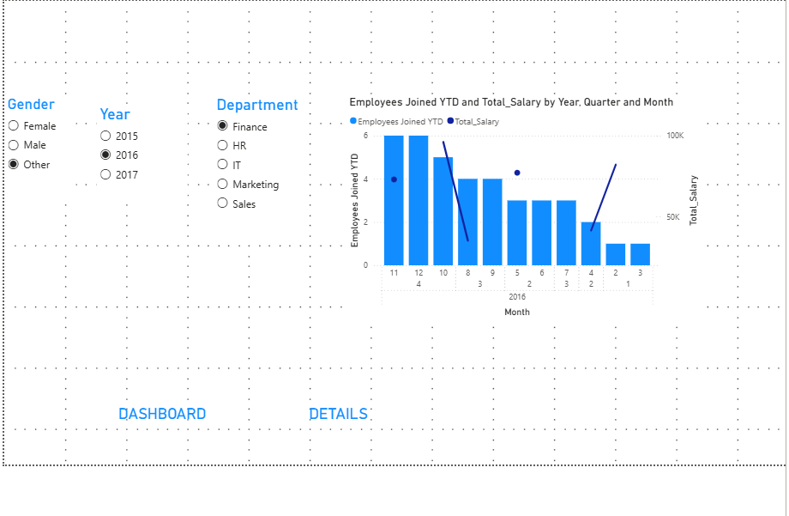
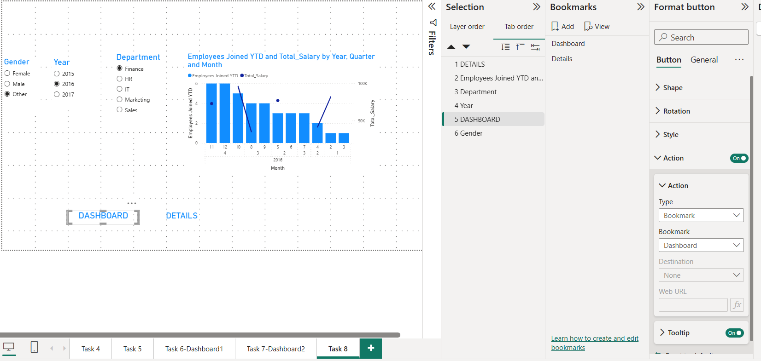
OBSERVATION:
- An interactive dashboard was created to analyze employee data efficiently.
- Slicers for Gender, Year, and Department enable dynamic data filtering.
- Drill-down functionality allows users to explore data from Year to Quarter and Month.
- DAX measures provide meaningful time-based insights and trend analysis.
- The clustered column chart clearly visualizes employee joining trends.
- Bookmarks and navigation buttons improve dashboard usability and navigation.
- Interactive filters help users focus on specific employee groups.
- The dashboard layout is organized, making the visuals easy to understand.
- Consistent formatting and titles improve the overall presentation quality.
- The dashboard is user-friendly, interactive, and effectively supports data-driven decision-making.

